**JOB DESCRIPTION**

_____________________________________________________________________________

_____________________________________________________________________________

**TITLE:** Horticultural Assistant **REPORTS TO:** Vineyard Manager or Course Superintendent

**DEPARTMENT**: Course Maintenance **FLSA STATUS:** Non-Exempt (Hourly) Exempt

Seasonal / part-time

**JOB SUMMARY:**

At Owl’s Nest Vineyard Course, we are dedicated to sustainable practices and creating a welcoming, supportive environment for both our team and visitors. We are seeking motivated and hardworking Vineyard assistants to join our team. This role involves hands-on work in the 9-acre vineyard, helping with various tasks to ensure the health and productivity of our grapevines.

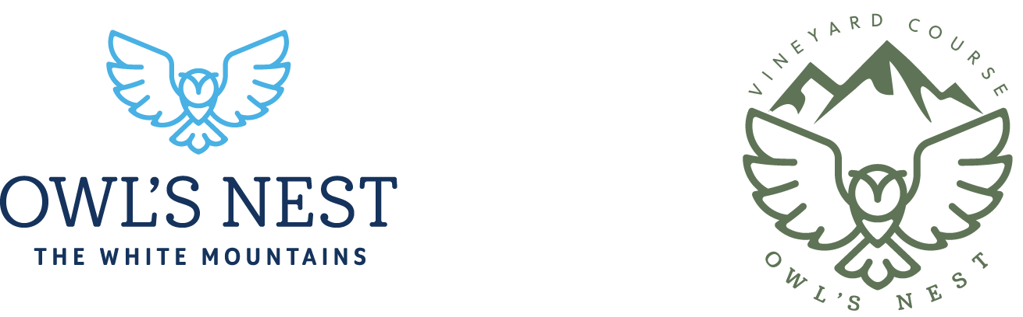**ESSENTIAL DUTIES AND RESPONSIBILITES**

* Assist with pruning and maintaining grapevines
* Support irrigation and pest management efforts
* Perform routine vineyard maintenance and upkeep
* Collaborate with vineyard manager and team members on daily tasks
* Ensure adherence to safety and quality standards

**The resort environment is unique in that we all share some degree of responsibility for each other and our role to collectively promote the resort in the best light possible. You will work consistently with other departments to create the overall brand image and are expected to be a team player who is willing to assist where appropriate and necessary.**

**KNOWLEDGE, SKILLS, AND ABILITIES**

* High School Diploma or GED.
* Preferred one year experience in an agricultural-related position.
* Demonstrate efficient problem-solving skills.
* Keep strong attention to detail and a willingness to learn
* Excellent communication skills both verbally and visually.
* Organization and strong attention to detail, positive attitude, and ability to work as part of a team.
* Experience in the resort/hospitality industry helpful.

**LICENSURE / CERTIFICATION REQUIREMENTS**

* Participate in ongoing education and training, especially related to viticulture.

**PHYSICAL REQUIREMENTS AND WORKING CONDITIONS**

* Ability to work a flexible schedule, which includes days, evenings, holidays, and weekend assignments.
* Must be able to lift and stack objects up to 75 pounds occasionally and frequently exert 10 to 30 pounds of force to lift, carry, push, and pull or otherwise move objects.
* Walking, sitting, and standing to a significant degree, reaching, handling, climbing stairs, balancing, pushing, kneeling, crouching, twisting/turning, bending at the waist, stooping, talking, hearing, seeing, and smelling.
* Tolerate, at times, extreme temperatures for one or more hours.
* Ability to work and handle stress arising from demands in production.
* Exposure at times to inclement weather.

*I understand that the job description is not a comprehensive list of my job duties, and it is up to me, along with my Manager’s guidance, to determine the best and most efficient way to accomplish my job duties and responsibilities. I also understand that should my job duties change significantly, which may occur based on the business needs of Owl’s Nest; it is my responsibility to notify the Vineyard Manager or Course Superintendent so that my job description is updated accordingly. I acknowledge that the job description will be used as the basis for my performance review.*

______________________________________

Signature

______________________________________

Printed Name

______________________________________

Date